Muhamad Assem Ahmed
Lab 17

Part A
LAB 17 — Lab ID: 27 | MIN_GPA_EDIT = 2.6 | MAX_YEAR_EDIT = 2

Create()'s GET overload isn't async because it does nothing but return an empty View() no database call and no await so there's no asynchronous work to wait on The POST overload calls AddAsync SaveChangesAsync which is why it needs async

Part B
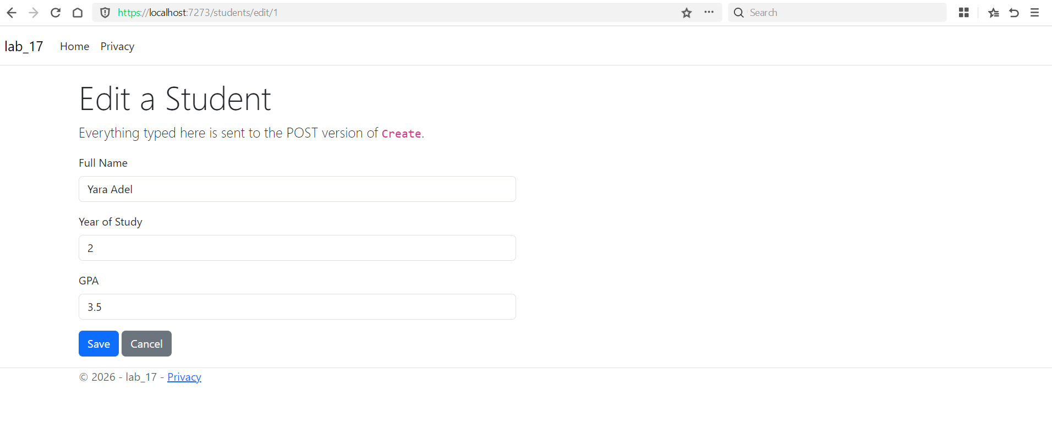

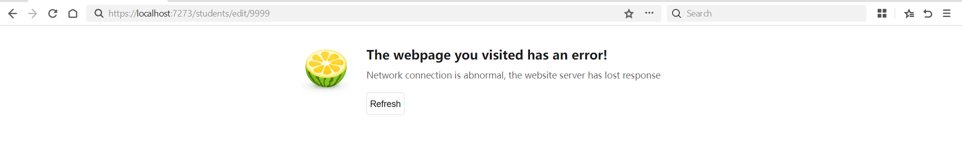
This loads the student from the database instead of rendering an empty form because Edit's whole point is to show what already exists

Part C
Before Update
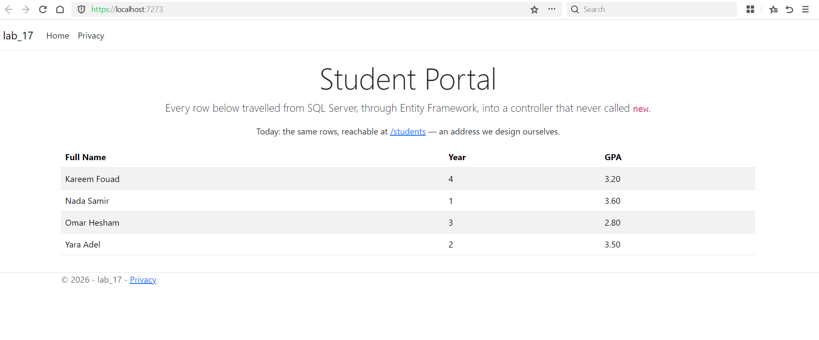

After :
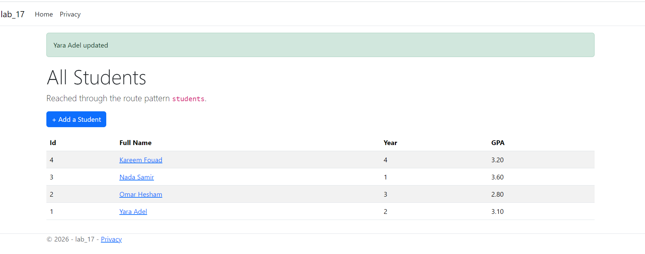
If id were renamed to `studentId` while the route still says {id}, model binding (which matches by NAME, not position) would find nothing called `studentId` in the route values and default it to 0. Since student.Id came from the form and is the real id, the guard clause's `id != student.Id` check would now always be true every edit would silently get rejected

Part D

[Range] is validation-only, not a schema attribute: changing its bounds never produces a pending EF Core migration, because it's never mapped to a database

Part E
I edited name to be include ’edit for part E’
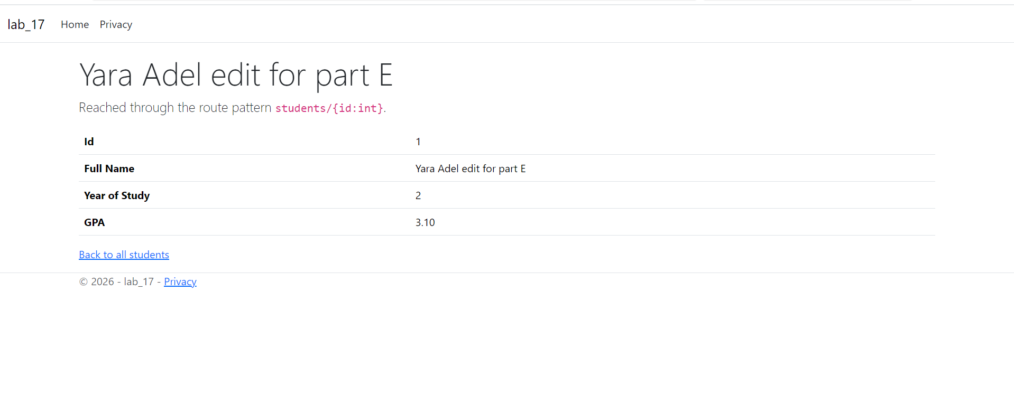

part F
Lab ID 27. MIN_GPA_EDIT = 2.0 + (27 mod 5) × 0.3 = 2.0 + 0.6 = 2.6 MAX_YEAR_EDIT = (27 mod 3) + 2 = 0 + 2 = 2 Route constraint(before any code runs) checks the shape of the URL. Validation / ModelState (before the action's first line) checks the shape of the data. Part D Database constraint (at save) checks the truth of the data. Before the save, the address bar held a POST to /Students/Edit, so F5 re-sent that POST. After redirecting to MuhamadAssemConfirmed the address bar now holds a GET to that action's address
both [Required]/[MaxLength] and [Range] are written as plain C# attributes directly above a property. Different: [Required]/[MaxLength] are schema attributes — EF Core maps them onto the actual database columnboth [Required]/[MaxLength] and [Range] are written as plain C# attributes directly above a property. Different: [Required]/[MaxLength] are schema attributes — EF Core maps them onto the actual database column
while [Range] is validation-only never touches the database schema while [Range] is validation-only
and never touches the database schema

